Serverless Machine Learning on Google Cloud Platform

Machine learning is a way to derive insight from data. We look at what machine learning is, how to build machine learning programs, how to think about machine learning programs, and also how to write transfer flow programs. We will step through transfer flow so that you can basically build your own transfer flow programs and execute them again in a cluster-less manner, fully managed on Google Cloud. We'll look at how to do hyperparameter tuning to improve your models, how to do feature engineering to create better features - again to improve your models.

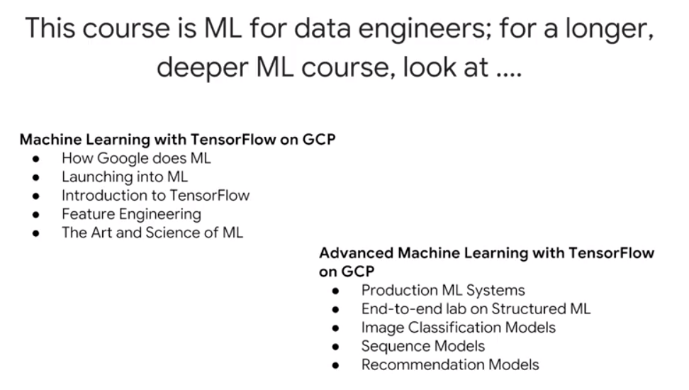

Machine Learning with TensorFlow on GCP: <https://www.coursera.org/specializations/machine-learning-tensorflow-gcp>

Advanced Machine Learning with TensorFlow on GCP: This course is apparently no longer offered

Deep Learning (DeepLearning.ai) – much more math-oriented: <https://www.coursera.org/specializations/deep-learning>

Fast.ai – highly recommended by several colleagues as being more hands-on and less math oriented: <http://course.fast.ai/>

## How to think about Machine Learning

Machine learning is a very general function. For example, with a neural network, you determine weights on that function which minimize some cost function. These are configurable parameters, these are tunable parameters. Parameters of the function are “tuned” based on a known dataset that represents a greater dataset. Then, apply this function that you have tuned on this known dataset and you use to predict unknown values.

Machine learning, or the approximation of this function is typically performed on a large amount of data, and it needs to be done scale. And that's something that Google Cloud does very well. What this class presents is machine learning on Google Cloud platform using TensorFlow and using Cloud ML. But you will also realize that with Cloud ML, you get serverless machine learning, which essentially means that the amount of configuration and work that you need to do is much reduced. You don't have to manage a cluster of machines, and you basically write TensorFlow code and you submit it to the cloud, and Cloud ML essentially takes care of whole of running it for you.

In this course you are introduced to the basics of machine learning. Then we'll delve into how you can apply machine learning to solve a particular problem.

# Module 1: Getting started with machine learning

## What is Machine Learning (ML)?

In this chapter, we define machine learning. We look at machine learning from the point of view of playing with it. That's one of the best ways to learn what something is. And then we will look at how to create effective machine learning models. And finally, we will create the machine learning datasets that we will use in the rest of this module.

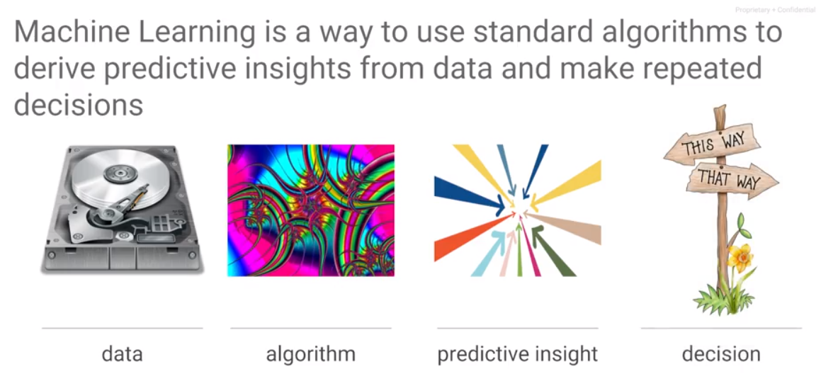 Machine learning is a way to derive insights from data. Given a large set of data and standard algorithms, you can use to obtain insight from the data. The kinds of insights that you would get from the data tend to be predictive in nature. That's the way I distinguish between things like business intelligence, which is all about historical data, trying to figure out what happened, and machine learning, which is about training the machine learning model on older data – that is true – but to be able to apply that model to unknown data, to be able to predict with it.

This concept of ML always being for image recognition is limiting, however useful it is in giving an example. ML can do far more than just recognize images – it needs to be generalized at least to the level of pattern recognition.

When you think about machine learning, you basically think in terms of what you want to accomplish with it. Let's say that what we want to accomplish is to take bunch of images and determine what's in those images. For example, for this image, is the animal a cat or dog. Or for the third image is the image a car or the output on the fourth image needs to be an apple. In order to do that, we need examples (supervised learning). An example in machine learning terms is a combination of the input, the input for which we want an output, and a label, which is a true output, the thing that we know, this is what it needs to be. For example, we have an image the label cat and the second image the label dog and the third image the label car. The pair of label and input together form an example. When training a machine learning model, we train it with examples which are combinations of labels and inputs. Once you have those examples, the machine learning model is a mathematical function that is trained. The way you train the model is that any of the mathematical models have free parameters, tunable parameters called weights, and you adjust those weights in such a way that the output of the ML model of this function matches the first image which is a cat and the second image which is a dog. If we had trained this model such that given this image the label were to be grass, that is what the ML model would learn. What the machine learning model does is lern the labels for a particular image. It determines a function such that that function given this input or given any of these inputs is going to match corresponding label. Given such a function, we can now give it a new image, an image for which we don't know the label, and the resulting function would give you a prediction, and that prediction is going to be the right output for this image.

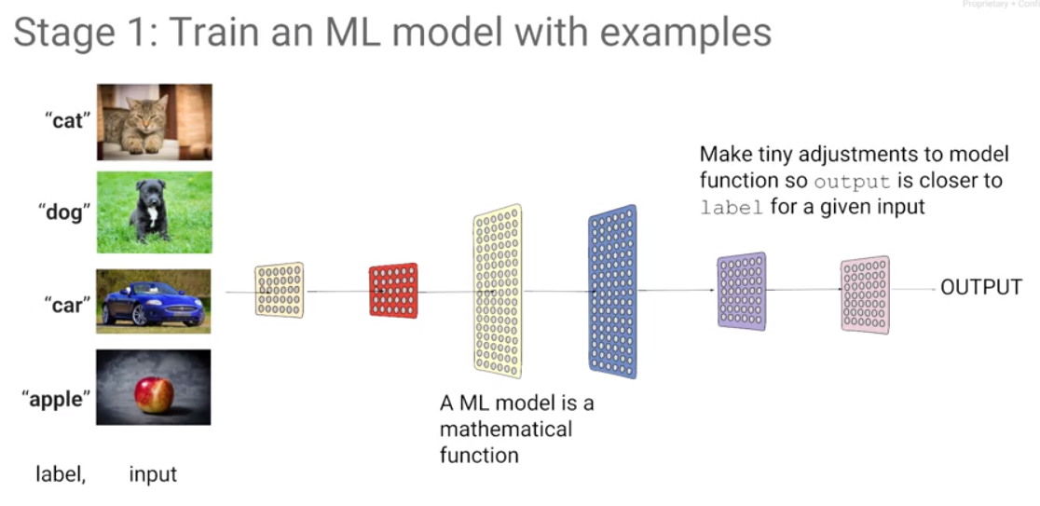

The whole idea of machine learning is that given a large data set of labeled data, adjust the mathematical model in such a way that given an input, the output for that input matches the original label. Then you don't need the training data anymore. All you need is a model, and you can take that model and apply it to an arbitrary image and hopefully what you get back is what you have trained that model to do on an image like that image. Predict with a model that has been trained.

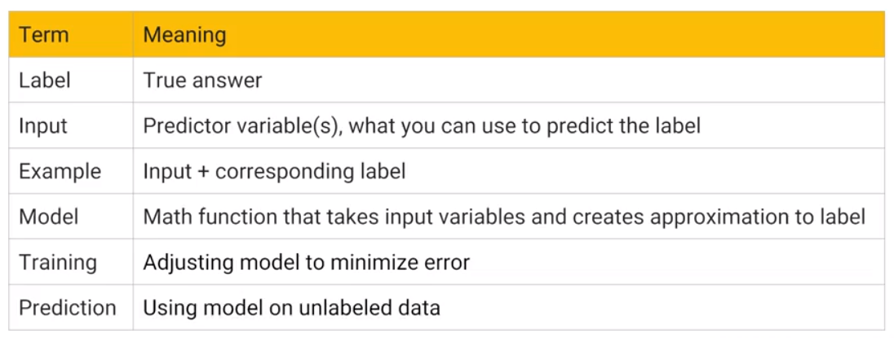

A label is the correct output for some input. This is what you train the model with. The label is a correct output for an input.

The input is the thing that you will know and that you can provide at the time of even prediction. These are the things, for example, if they're images; the image itself is an input.

An example is a combination of label and input. An input and its corresponding label together form an example.

A model is this mathematical function that takes an input and creates an output that approximates the label for that input.

Training is this process of adjusting the weights of a model in such a way that it can make predictions, given an input.

Prediction is this process of taking an input in and applying the mathematical model to it, so as to get an output that hopefully is the correct output for that input.

Supervised learning is learning by example. There's another type of machine learning use case, where you don't have labels. That’s called clustering. For example, you may have the data, as the data on the left, you may have some data on people. Every dot here is a person at a company. We know the number of years they have spent at the company and we know their income, and we can look at this data and we feel that this data falls into two big categories: one category of people whose income rises much faster than this other category of people. And we may say anybody in this grouping is on the fast track at this company. But that's not a label, because we don't know the truth. This is just looking at the data and trying to divide it into two classes. This is the last time that we are going to look at unsupervised learning. The rest of this course, we are going to focus on supervised learning.

A very common source of structured data for machine learning is a data warehouse, e.g., BigQuery. We can do a select statement in BigQuery to create this data set such that we can use it to train a model. This is a very common use case - this is a use case that we are going to focus on in this module. We are going to be looking at structured data prediction for machine learning. You have a trained model, how does prediction work in a structured data problem?

The simplest model that is capable of doing something like this may have exactly just one layer, and that layer is a layer of weights. We add b, a constant that we will call the bias. This may be the entire mathematical model and you can see that we could probably adjust these weights in such a way that for any of these rows in the data, we can achieve the desired output. We can choose a regression model or a classification model.

Given this input and this label, our training data set, we take our mathematical model and change the weights of this mathematical model in such a way that given any of these inputs, the output is as close as possible to the label that we have. For classification, a case is true or false (represent as one and zero), make a computation, a weighted sum, and that's our mathematical model. How does it work for unstructured data? How can we do a weighted sum of an image? Even an image, you can think of as a two-dimensional array of pixels and each pixel has red, green, blue and alpha, so four numbers. If you have an image, an image is a tensor.

What about if you have text? How does the word still become a number? Now that's a little bit harder. Take any word and map it to be a vector, e.g., the word "the" can be represented by the numbers [0 4 5 0 3 4]. We could assign arbitrary numbers to every word in the dictionary, but that is not ideal. It is not ideal because you would like to say that the word, the vector representation of plenty and the vector representation of many and the vector representation of much should all be relatively close to each other and should be very different from the vector representation of seeing because the word "seeing" and "plenty" are not as closely related as the word "much" and "plenty". This itself turns out to be a machine learning problem of assigning an appropriate vector to appropriate words in a language, but fortunately that's been done before. For a machine learning problem with freeform text as input, use word2vec, one of these techniques to convert words to vectors. Typically, there is a different word2vec for different languages, so you would go ahead and pick one of those word2vec objects and use it to convert your text into vectors. From there, you have numbers and use those as input to the machine learning problem.

Even though we are focusing primarily on structured data in this course, the treatment of other objects such as images and text uses the same concepts. As it turns out, the kind of layers and the kinds of things that you would do would be somewhat different, but we're not going to talk about those, we're going to stick very much to the basic concepts of machine learning and applying it to structured data machine learning, which is the most common kind of data problem that you would face in most businesses. To learn ML, learn it on structured data because it tends to be the most useful.

If you have a classification model, the labels are Boolean values (0 or 1) but the output of the model will be a number between zero and one. How do we interpret that number? We interpret that number as a probability such that if this probability is being one or zero. Given this framing, for a labeled data set with a known output for each of those inputs, we can now create a machine learning model, a mathematical function that will be able to create an approximation of that label for every one of those inputs.

## Types of ML

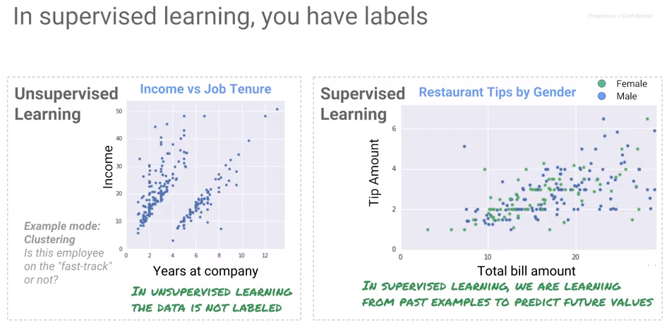

Supervised learning is learning by example. Another type of machine learning does not have labels. That's called clustering. This is just looking at the data and trying somewhat arbitrarily dividing it into different groups.

In this course, we concentrate on supervised learning where we have a label and we know the true outcome for some input. If the problem is to calculate an amount that is a continuous number, it is a regression problem. On the other hand, if the problem is to assign a categorical value out of a discrete (usually two – e.g., True and False) set, then it is a classification problem.

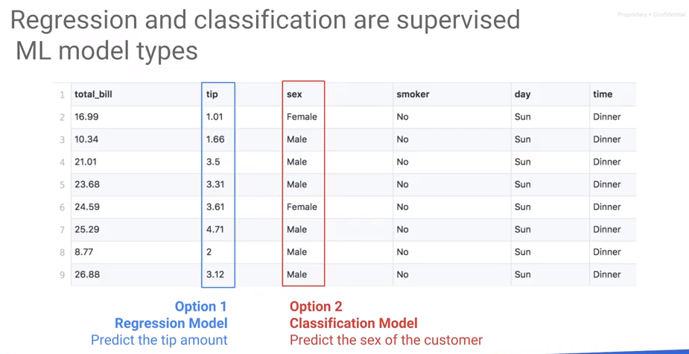

## The ML Pipeline

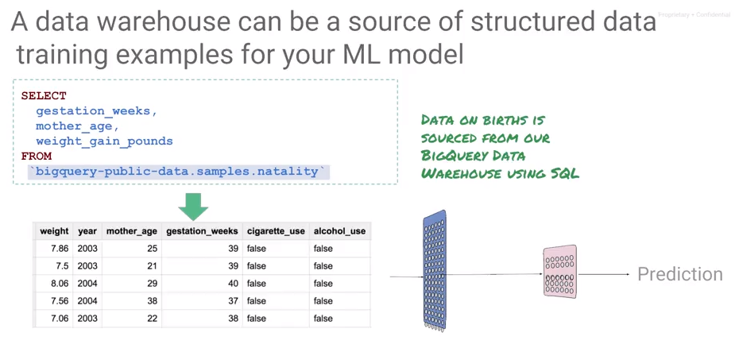



Here's another example of a regression model that predicts a continuous number. This is a dataset on babies that were born. And we know the mother's age, and the weight gain in the pregnancy so far. And based on this data set, we want to predict how long the gestation period is going to be? How long is a pregnancy going to last for this model? Now, where does this data come from? This is what we would call structured data. And a very common source of structure data for machine learning is your data warehouse - in this case, BigQuery. We can go ahead and do a select statement and BigQuery to create this data set such that, we can use it a train model that predicts the gestation weeks, given all of these attributes of the pregnancy. This is a very common use case and this is a use case that we want to focus on in this module. What are going to be doing, is we're going to be looking at structure data prediction for machine learning. Because what we're trying to predict is the gestation weeks and that is a continuous number, this model that takes the mother's age, the weight gain in pounds, the model that takes these two inputs, and uses it to predict the gestation weeks, this model is a regression model. Having created a data set, we next train a regression model based on data, in our data warehouse. Once you've trained a model how does prediction work in a structured data problem. Well, remember that you trained a model on two inputs; mother's age and weight gain in pounds. If you want to do a prediction, you need to have the person who requires a prediction, the mother. Or it's usually computer's application making the prediction on behalf of this patient. That application needs to give you those two input parameters. And the machine learning service will give you back the predicted gestation weeks. In other words, the inputs are going to be the mother's age, and the weight gain in pounds. And I'm showing it to you here as json input. This is presented to the machine learning model, which applies the mathematical function and outcomes the gestation period, because that's what the model was trained to predict.

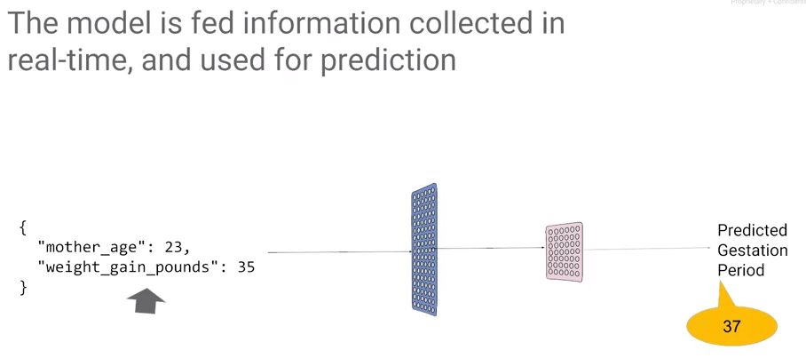

## Variants of an ML Model

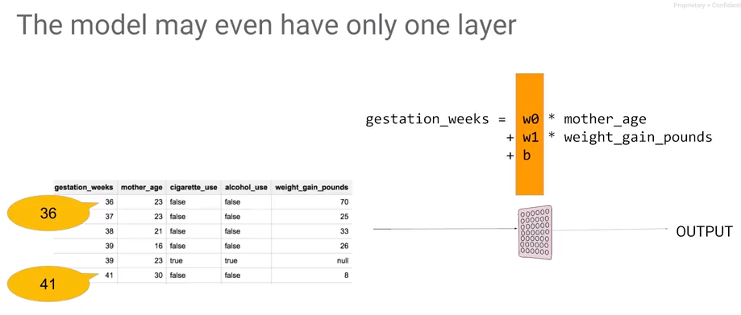

The simplest model is one layer of weights. We can write the mathematical function as gestation weeks is weight zero times the mother's age, plus weight 1 times the weight gain in pounds plus B, a constant that we will call the bias. This may be the entire mathematical model, and you can see that we could probably adjust these weights in such a way that for any of the rows in the data, the gestation weeks that we get by applying this formula to the two columns, is as close as possible to the gestation week for that role. The other type of model besides the regression model is a classification model. For example, given the text of an e-mail and the label, predict if it is spam or not.

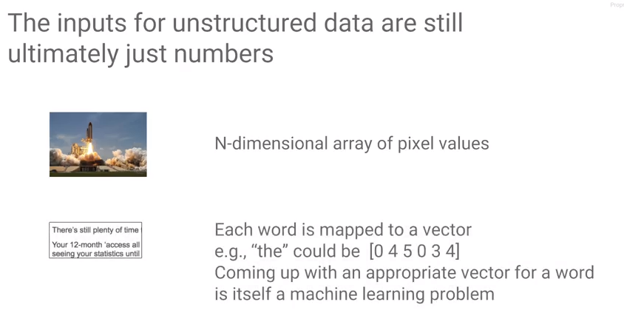 How does this work if the inputs are images or text? Everything that goes into a machine learning model has to be numeric. But how does it work for unstructured data? How can we do a weighted sum of an image? An image may be represented as a two-dimensional array of pixels and each pixel has red, green, blue and alphas for numbers. An image is a three-dimensional array of numbers. A 1D array is a vector, a 2D array is a matrix, a three dimensional - in general we call an n-dimensional array a tensor. That is where the name TensorFlow comes from. An image is a tensor.

What about if you have text? How does the word still become a number? Now that's a little bit harder. Take any word and map it to be a vector, e.g., the word "the" can be represented by the numbers [0 4 5 0 3 4]. We could assign arbitrary numbers to every word in the dictionary, but that is not ideal. It is not ideal because you would like to say that the word, the vector representation of plenty and the vector representation of many and the vector representation of much should all be relatively close to each other and should be very different from the vector representation of seeing because the word "seeing" and "plenty" are not as closely related as the word "much" and "plenty". This itself turns out to be a machine learning problem of assigning an appropriate vector to appropriate words in a language, but fortunately that's been done before. For a machine learning problem with freeform text as input, use word2vec, one of these techniques to convert words to vectors. Typically, there is a different word2vec for different languages, so you would go ahead and pick one of those word2vec objects and use it to convert your text into vectors. From there, you have numbers and use those as input to the machine learning problem.

Even though we are focusing primarily on structured data in this course, the things you do for images and text, the concepts still apply. As it turns out though, the kinds of layers and the kinds of models and the kinds of tricks that you would do for images and text are different, which is why we have this whole 10 course specialization on machine learning. In this course, we are going to stick to the basic concept of machine learning and applying it to structured data machine learning, which is the most common kind of data problem that you will face in most businesses. If you're going to learn machine learning, learn on structured data, because it tends to be the most useful. If you have a classification model, the labels would be spam or not spam, and the output of the model will not be 0 or 1, the output of the model will be a number between 0 and 1. It would be a floating-point number between 0 and 1. How do we interpret that number? What we do is because we decided the spam was going to be 1 and not spam was going to be 0, we'll interpret that number as a probability. That if this probability is 1 if it's 100 percent likely to be spam, and if the probability is 0, it is 100 percent likely to be not spam and if it's a number between 0 and 1, the number is 0.8, then we say that it is 80 percent likely that this image is spam. So, we interpret the output of the model, this output that's between 0 and 1, we interpret it as a probability of it being label equals 1.

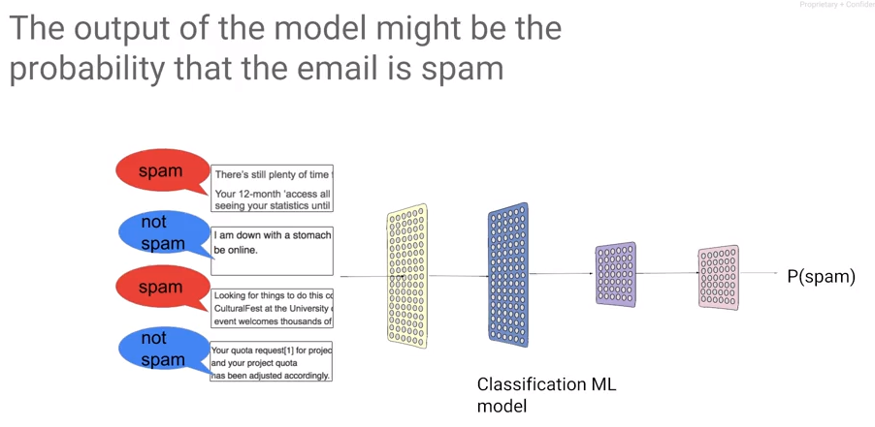

## Framing an ML Problem

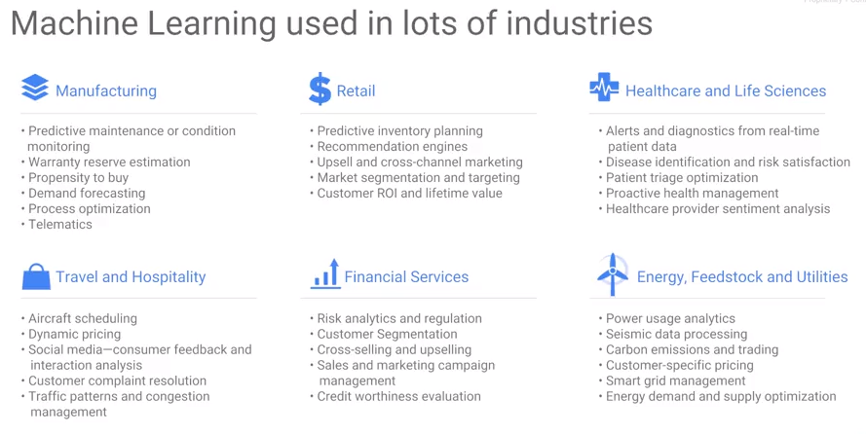

Consider this: you have a labeled data set, a data set of inputs, and the true known output for each of those inputs. Given such a training data set we can now create a machine learning model. The machine learning model is a mathematical function that will be able to create an approximation of that label for every one of those inputs. And then you can take that model and use it on inputs for which you are interested in knowing what the output ought to be. Given that framework, ML turns out to be extremely useful in a lot of different industries.

## Playing with Machine Learning

In this section, we develop an intuitive understanding of what neural networks are, what neurons are, what gradient descent is, etc.

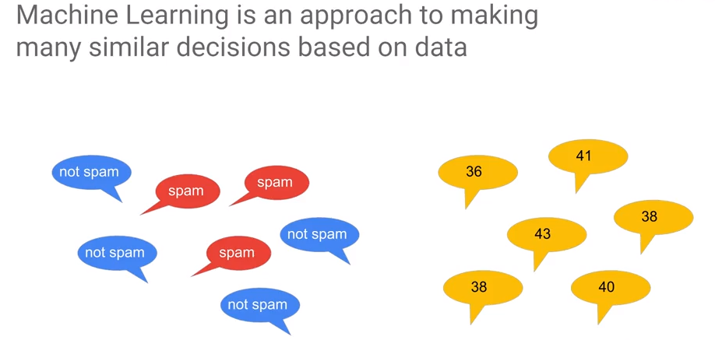Machine learning is a way by which we make a lot of very similar decisions based on data. Machine learning is not about making one off decisions.

The statement above is generally correct. However, the author gave an example that is incorrect. He stated that the problem cannot be used to find delays in supply chain – this is the problem of finding anomalous behavior which can be handled well by classification. Indeed, many problems can be dealt with when using modern analytics.

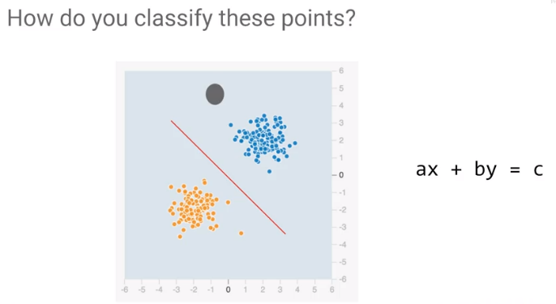Machine learning is ideal for handling cases where outcome is consistent based on data.

For example, let the blue dots represent spam and the yellow dots are not spam. The topology of this problem makes it easy to find a solution. How would you classify these points? You would draw a line. And you would say that everything below this line is whatever the class is that corresponds to orange. And every point that's above this line is whatever the class is that corresponds to blue. Let's say all the blue are not spam. The equation of a line is ax + by = c you has two weights b and c. The intercept or bias is a constant. In terms of a neural network, if we have two inputs, x1 and x2, we can find a weight, w1, that we apply to x1, a weight, w2, that we apply to x2, and we can check if it's greater than some bias. That is, ax plus by, is it greater than c?

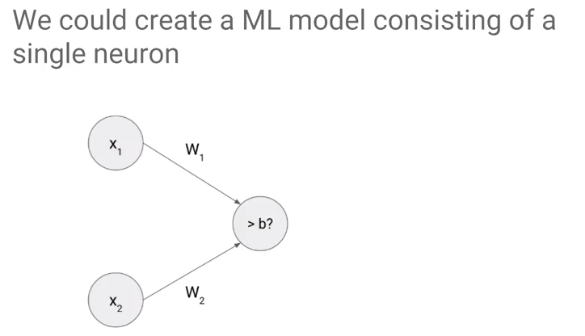The object which collects the inputs and adds weights is called a neuron. A neuron is a way to combine all of the inputs and make a single decision on those inputs.

Graphically, a single neuron w1x1 + w2x2 is it greater than b, that single decision translates to be a line. This is the line separates the two sets of points.

## Optimization

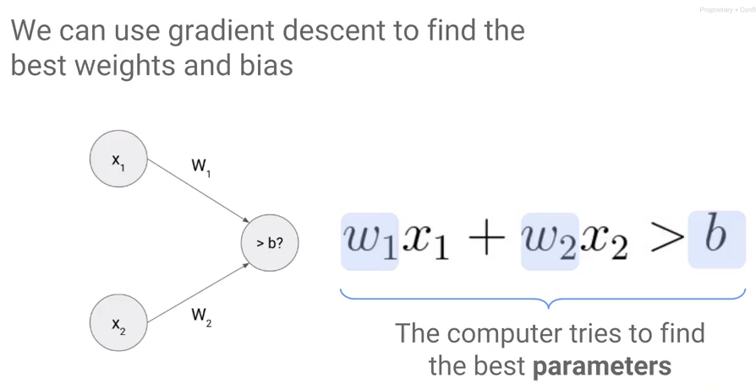

|  |
| --- |
| **Gradient Descent is Iterative** |

To find values for w1, w2 and b, use a process called gradient descent. With gradient descent, we walk down an error surface, hoping to end up at the place where the error is minimum. Visually, the idea being the more the points are distant from the separation line, the better it is.

Depending on what direction will reduce the error (moving us towards the minimum), we decide what the next value of the weight is going to be, because in this case, increasing the weight resulted in a lower error at the next iteration where we start is at that increased weight. So, we started the next iteration, we will repeat the process again and ultimately, we land up at the minimum. This isn't guaranteed though. Maybe when we change the weight, our change is so small that it takes a very large time to converge. The model takes a long time to train and so we give up and we don't actually end up at the best possible error. The size of the changes we make to the weights is called the learning rate. When the learning rate is low, training takes a very long time. If you try to speed things up by increasing the learning rate, we might miss the minimum altogether, so that's not good either. What we need is a perfect learning rate. The best learning rate unfortunately varies from problem to problem, so you will have to experiment.

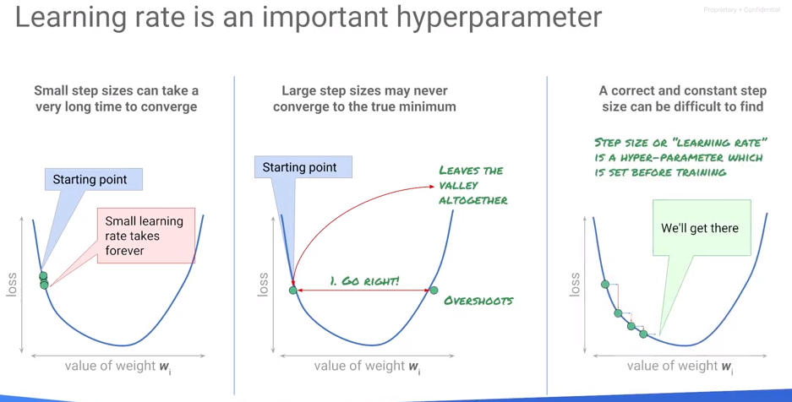Learning rate is an example of what is known as a hyper parameter. We look at hyper parameter tuning in a later module of this course. Let's look at the process of training a machine learning model. Start with random weights, calculate the error on a dataset for which you know the answers - the labeled dataset. Calculate the error on the label dataset and then we change those weights, and we try out different changes of weights in the neighborhood of that arbitrary weight that we started off with. Change them so that they're going to a direction where the arrow goes down, and then we go back and we calculate the error again. We tweak the weights and we calculate the error again, and we tweak the weights and we do this over and over again. Now when we do this tweaking of the weights, do we have to do it over the entire training dataset? Well, we could, but doing great in descent on the entire training dataset will tend to be quite slow. Your dataset may be many millions of rows long, and if every tweak requires you to go ahead and calculate the value of the error on all million rows, it will be quite slow. 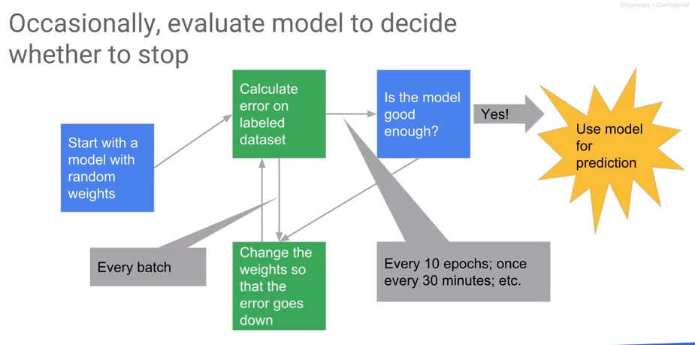

Instead, tweak the weights on a small batch of training data. Typical sizes of batches tend to be like 30 to maybe about 500 cycles. We calculate the errors, iterate through the weight changes, and then we have to decide when to stop. Because gradient descent is not guaranteed to converge, this gets to reasonable stopping point. Every once in a while, you want to determine if the model has converged sufficiently. Convergence should be checked every n epochs - an epoch is a traversal through the entire training dataset. If the model is good enough, then you stop, you export the model and you use the model for prediction.

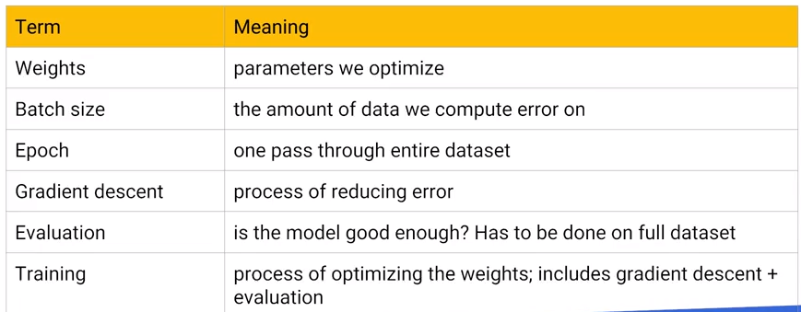

## A Neural Network Playground – Choosing Network Configuration

[http//playground.tensorflow.org](http/playground.tensorflow.org)

For ANN/DNN topology, see <https://github.com/jeffreyrnorton/GoogleCloudPlatformNotes/blob/master/NeuralNetworkOverview.md>.

Rest of the lecture ignored – if you want it - <https://www.coursera.org/learn/serverless-machine-learning-gcp/lecture/NtKiH/a-neural-network-playground>

## Combining Features

Also ignored – for the lecture see <https://www.coursera.org/learn/serverless-machine-learning-gcp/lecture/x6N1c/combining-features>.

This lecture is pretty trivial. It talks about building up features support by adding more neurons. Take a look at the topology link above instead.

## Feature Engineering

The term feature engineering refers to transformations made on problem features to create features. For example, it is pretty common to normalize measures to obtain numerical stability. Another method is to generate new features. For example, if I have temperature T, and it is measured over time, I can create a feature ΔT/ Δt, that is, the change of temperature over time.

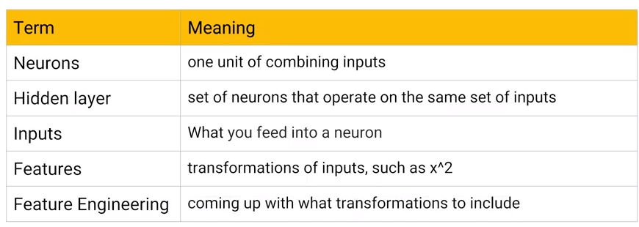

## Image Models – Modeling multicategory problems

Multi-category refers to the problem where an input may fall into multiple categories. For example, the MNIST image recognition problem classifies an input as *one of* 0-9.

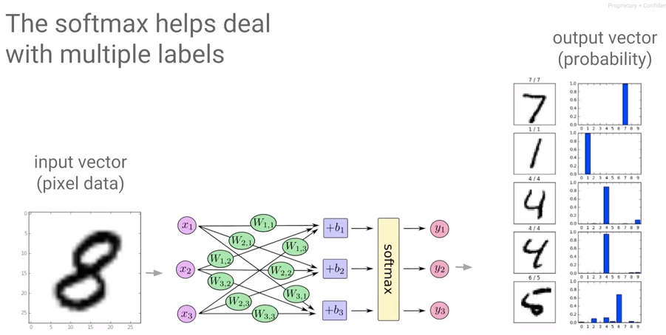

Softmax – The term is introduced, but never explained. This is from Stanford: <http://ufldl.stanford.edu/tutorial/supervised/SoftmaxRegression/>.

Softmax regression (or multinomial logistic regression) is a generalization of logistic regression to the case where we want to handle multiple classes. In logistic regression we assumed that the labels were binary: y(i)∈{0,1}. We used such a classifier to distinguish between two kinds of hand-written digits. Softmax regression allows us to handle y(i)∈{1,…,K} where K is the number of classes.

## Effective ML

Effective ML follows these steps:

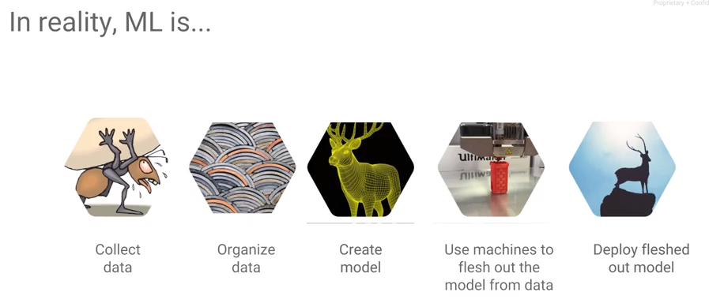

## What makes a good dataset?

1. The dataset should cover all cases.
2. Negative examples and near misses.

Then, explore the data you have and fix problems, e.g., impute missing data.

## Error Metrics

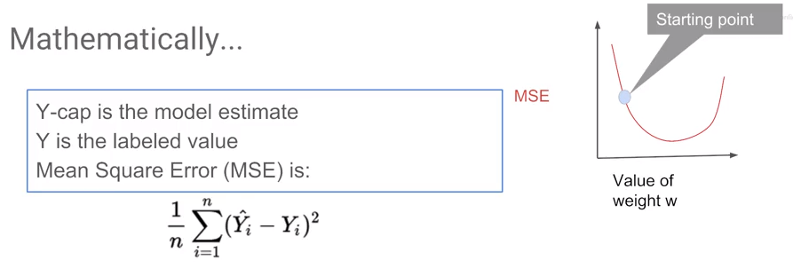

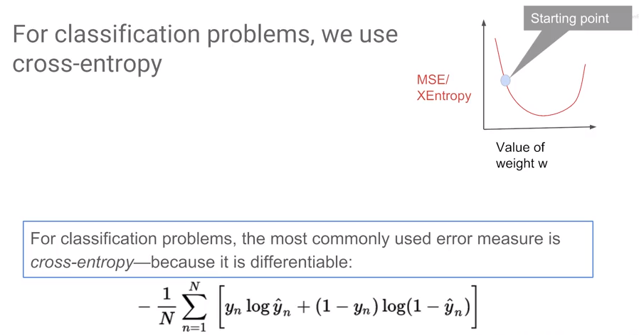’See also <https://deepnotes.io/softmax-crossentropy>.

## Accuracy, Precision, and Recall

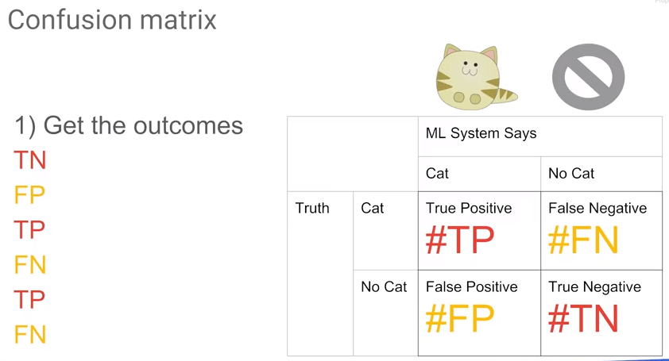

<http://www.saedsayad.com/model_evaluation_c.htm> gives a nice overview of the Confusion Matrix, AUC, etc.

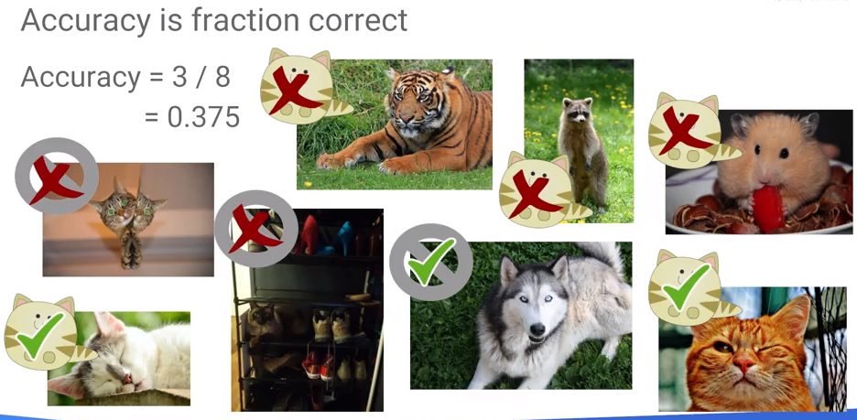

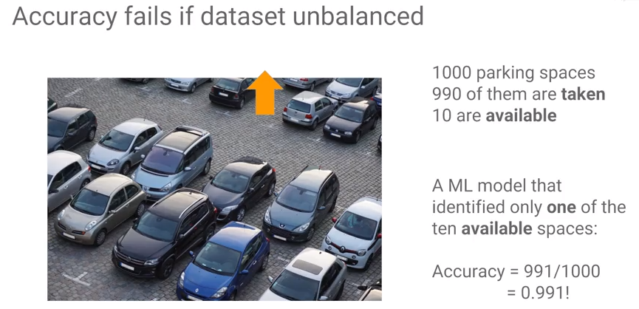

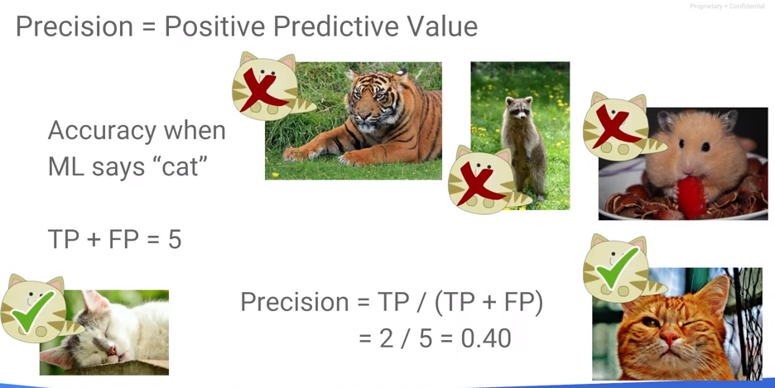

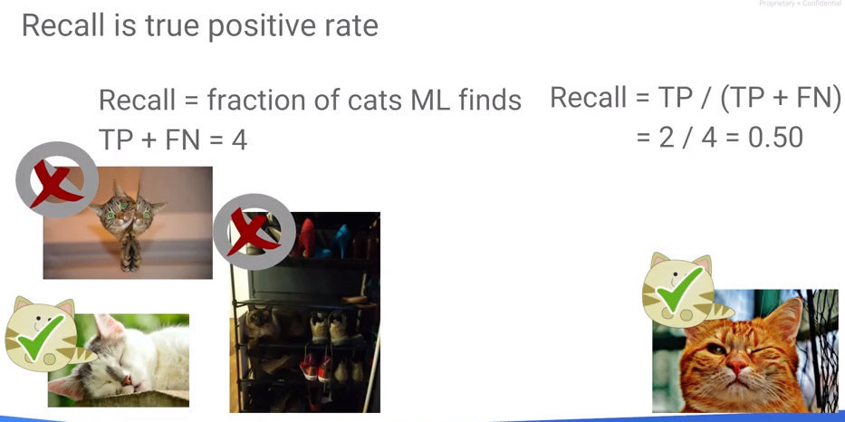

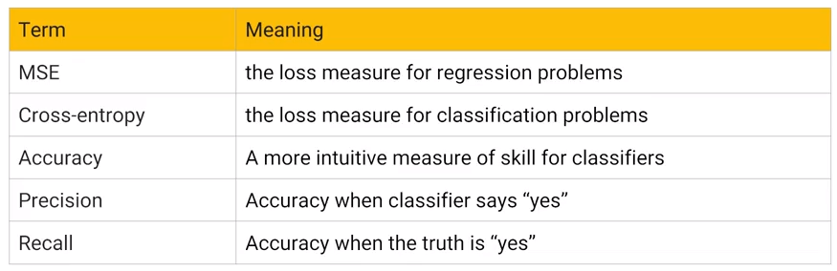

## Creating Machine Learning Databases

A review of the quality of fit – especially with regards to overfitting.

#### Training

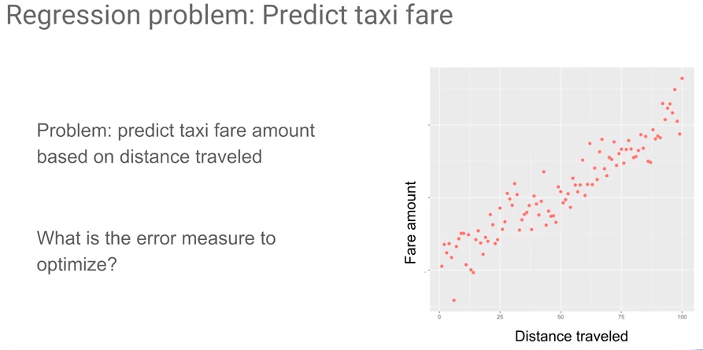

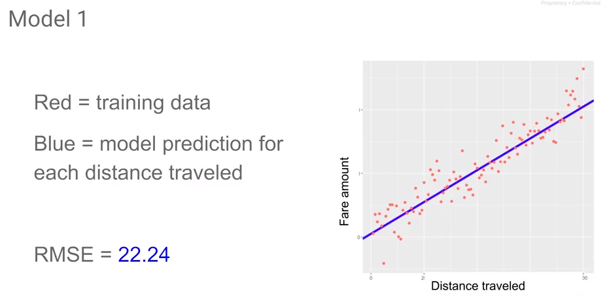

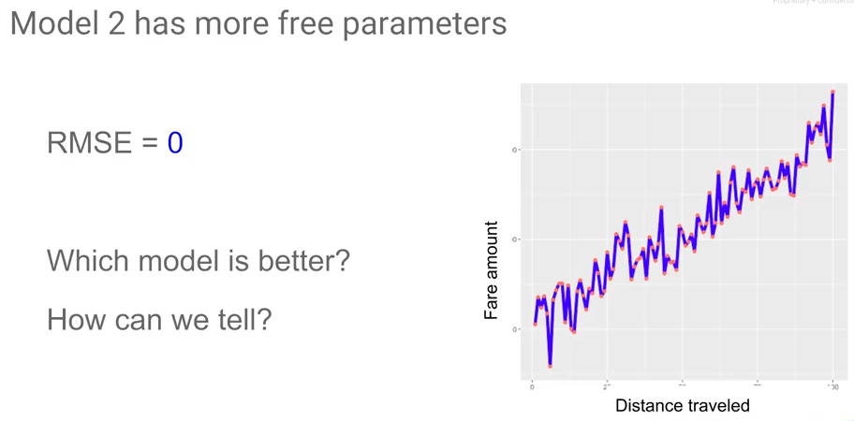

#### Testing

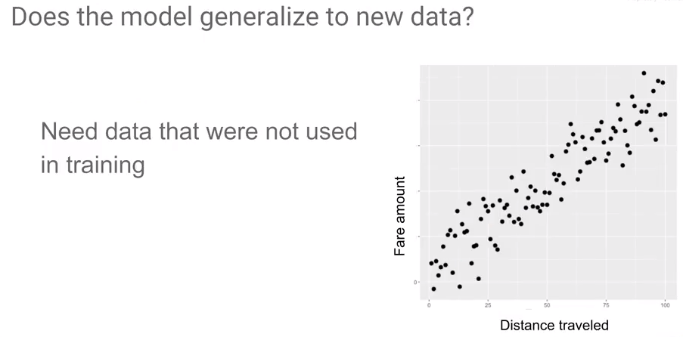

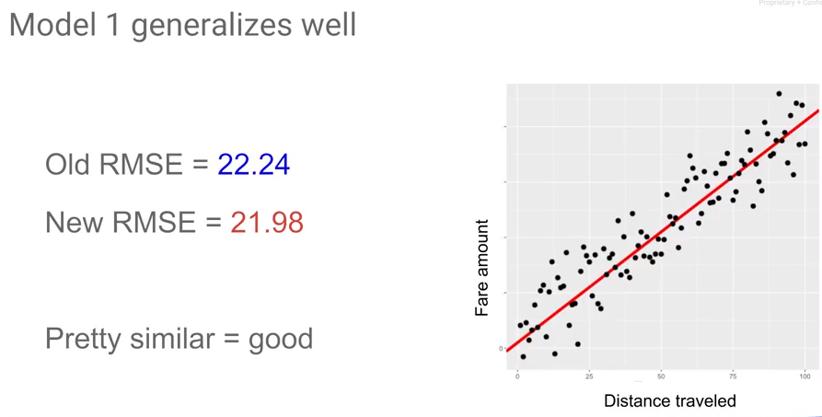

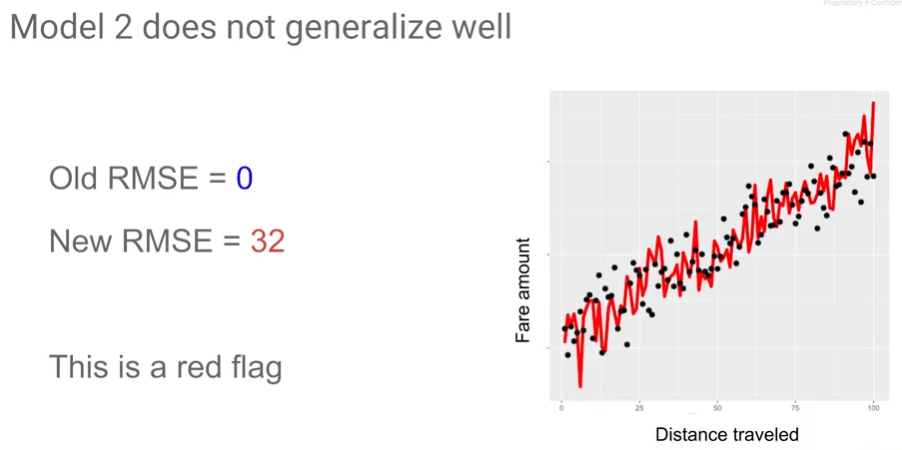

## Splitting the Data Set

Split the data (usually randomly) into training and testing sets. Usually put more data into the training set.

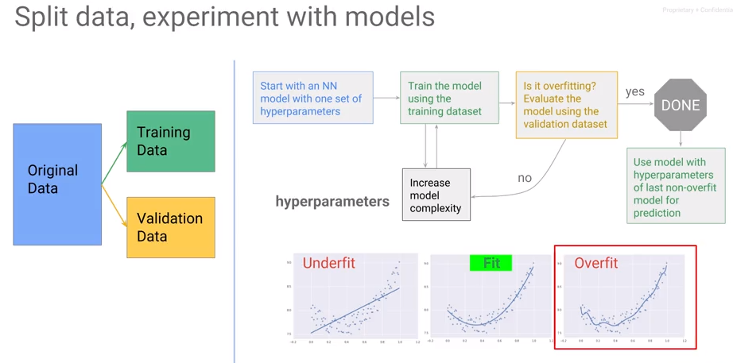

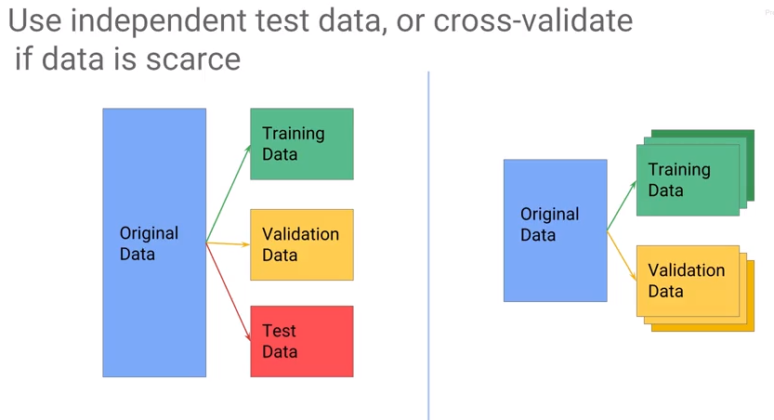

Cross Validation - <https://en.wikipedia.org/wiki/Cross-validation_(statistics)>

Related, Bootstrapping - <https://en.wikipedia.org/wiki/Bootstrapping_(statistics)>.

## Lab

<https://github.com/jeffreyrnorton/GoogleCloudPlatformNotes/blob/master/labs/create_datasets.ipynb>

Review: <https://www.coursera.org/learn/serverless-machine-learning-gcp/lecture/wcAv8/create-ml-datasets-lab-review>

# Module 2: Building ML Models with TensorFlow

## What is TensorFlow?

In this module, we learn about TensorFlow and how to use TensorFlow to build ML models. Then we will look at how to write distributed TensorFlow models to run on a number of machines, rather than just on a single machine.

TensorFlow is an open source library. It provides a way to write code that works on a variety of different hardware architectures including CPUs, GPUs, and TPUs (tensor processing units – see <https://cloud.google.com/blog/big-data/2017/05/an-in-depth-look-at-googles-first-tensor-processing-unit-tpu>.

With machine learning and TensorFlow, there is the aspect of training and that of predicting and they are separable. For example, you may train on one of more (powerful) machine(s) and predict on a mobile phone. TensorFlow writes the numerical code that represents in graphs and can be executed anywhere.

TensorFlow is written in C++. That is the part that is portable – often run on a virtual machine. It is written in C++ for portability reasons and additionally runs very efficiently. The TensorFlow core has a Python wrapper. TensorFlow presents a low-level interface in Python that can perform numerical and matrix computations. Additionally, it provides a method for defining layers in the neural network.

There is a high-level API – the estimator API. We will use the estimator API. This presents a method to use higher level extractions metrics, etc. Or you can use something more object.

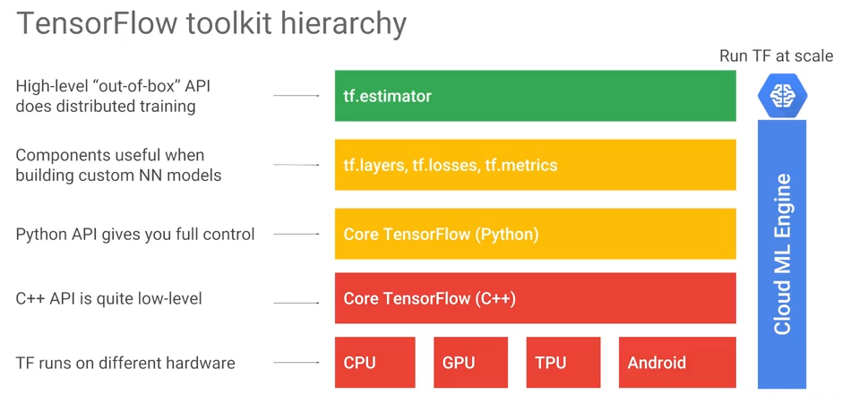

As an example, the core or lower-level Python API for TensorFlow allows us to add two objects called tensors and get a new tensor. What is a tensor?

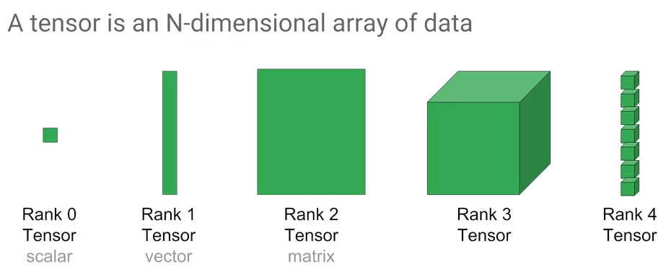 A tensor can hold data of any dimensionality. However, it is really just a placeholder. Feed in actual values for two input tensors. To calculate the resultant, run a session and then you get the equivalent of a NumPy array output…

## Core TensorFlow

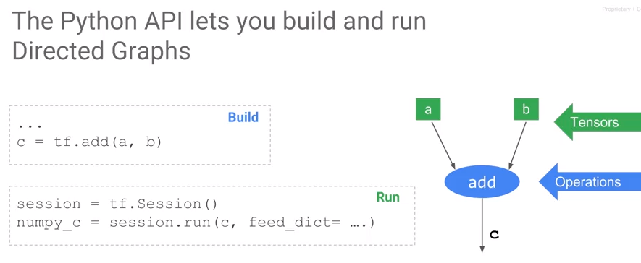

The core python API for Tensorflow looks like just numpy. To add two tensors a and b write "tf.add(a, b)" which returns a tensor c. Unlike typical Python code, running tf.add doesn't execute it. It only builds a directed graph. In the directed graph a, b and c are tensors, add is an operation. To run this code or execute the directed graph run it as part of a session, that is, direct a session to evaluate c for you.

Programming TensorFlow involves programming a directed graph. There are two steps:

1. create the graph.
2. run the graph.

A graph definition is different than numpy because this is a lazy evaluation model. It minimizes the Python C++ context switches and enables the computation to be very efficient. To some extent, this is like writing a program, compiling it, and then running it on some data. Note that c, after you call tf.add, is not the actual values. You have to evaluate c in the context of a TensorFlow session to get a numpy array of values "numpy_c".

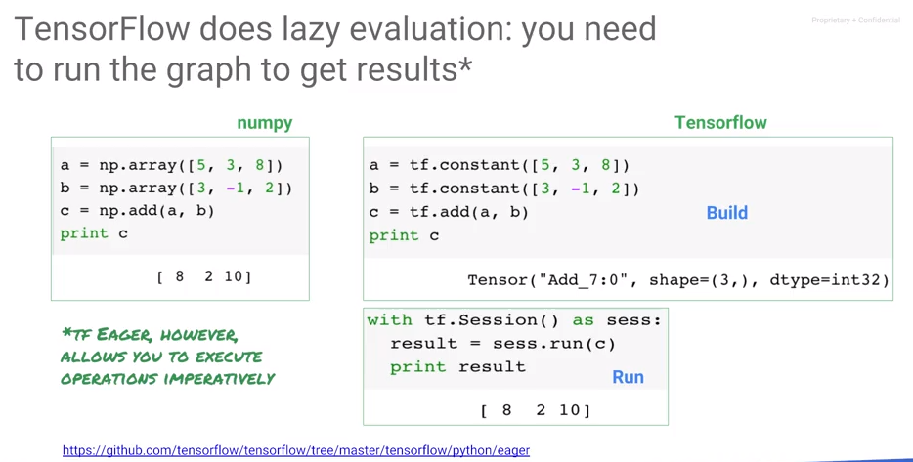

To reiterate, TensorFlow does lazy evaluation. Write a directed graph, then run the directed graph in the context of a session to get results. There is a different mode in which you can run TensorFlow called "tf eager", where the evaluation is immediate, not lazy. Eager mode is typically not used in production programs – it is typically used only for development.

The majority of Python numeric software is written numpy, matrix implementations use C++ libraries to provide performance advantage. np.add is evaluated immediately. Unlike numpy, in TensorFlow the tensor is not the actual values, instead c is a placeholder for the tensor. Operations are held in a directed graph and operations are not carried out until the session is executed. When we print a placeholder, what gets printed out in the first box is a debug output of the tensor class. It includes a system assigned unique name for the node on the directed graph, the shape and data type of the value that will show up when the directed graph is run.

TensorFlow separates out the creation of the graph from the execution of the graph. The way the graph is executed doesn't have to exactly match the way you specified it in the code. For example, between the matmul node and the add node, TensorFlow might insert, send, and receive nodes into the graph. The matrix multiplication can send graph instructions to another machine for execution. This ability to change the graph is important. But besides preparing a graph for execution on multiple hardware devices, TensorFlow can also process the graph to add quantization, debug nodes, create summaries. For example, graphs can be compiled to fuse operations to improve performance.

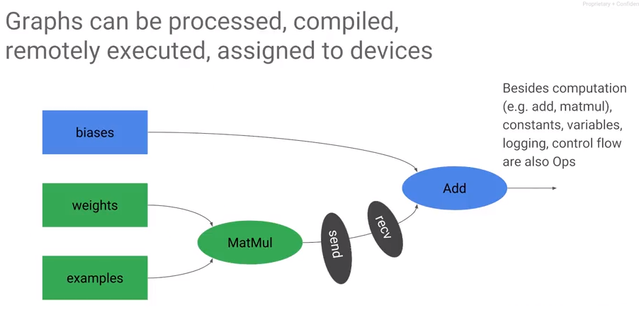

## Lab: Getting started with TensorFlow

Review: <https://www.coursera.org/learn/serverless-machine-learning-gcp/lecture/oe7KB/tensorflow-lab-review>

## Estimator API

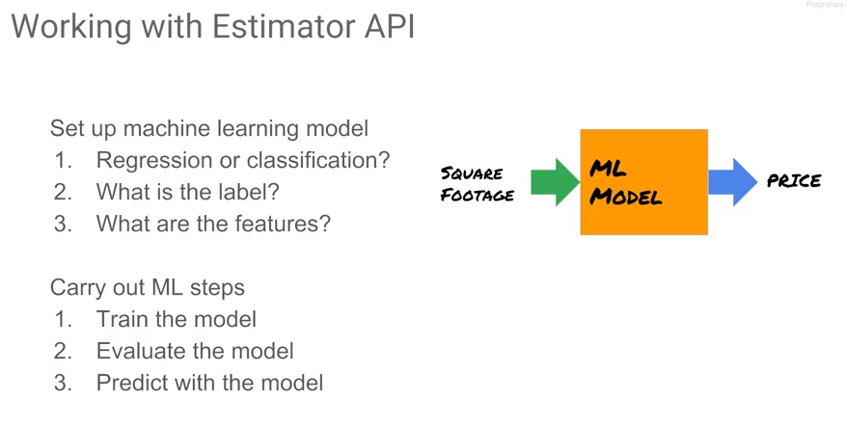

Now that we've looked at Core TensorFlow, let's look at how to use TensorFlow for machine learning. We will skip all the way to the top of the hierarchy and we look at the Estimator API. With the estimator API, the first step is to setup a machine learning model. Is this a regression problem or is this a classification problem? What's the label? What are the features? Consider the example that tries to predict the price of a house given the area of the house, the square footage of the house. This is a regression problem because we're predicting a price which is a continuous number. For each house, we have square footage and the price that the house sold for. The label is the price. There is one feature which is a square footage of the house.

Once you set up a machine learning model in this form, whether it's regression or classification, determine the label and features, then you perform three steps:

1. You train the model, you adjust the weights of the model in such a way that the output of the model for a given input is very close to the label for that input
2. evaluate the model to figure out how well this model actually works
3. predict with the model. 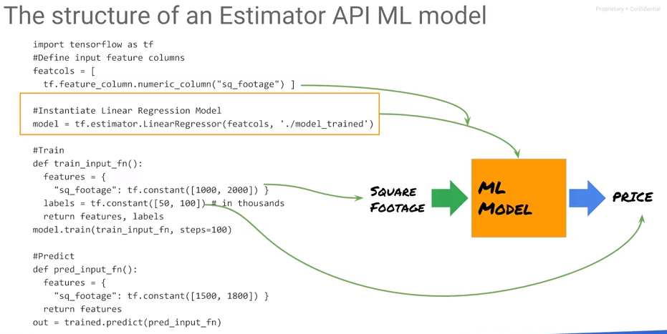

Code Outline:

1. TensorFlow as TF. Let's ignore the feature columns for now.
2. Regression model or a classification model. There are other regressors other than linear regression. Regressor for regression problems, classifier for classification problems. Estimator is a linear regressor with a specific set of columns.
3. What are those columns? The feature columns are define using a list.
4. With this estimator, we train the model. The way to train the estimator is to call the fit function on the estimator, passing in a way for it to go get all the training data. The input function is a way for the estimator to be fed in all of the input data which in this case is a dictionary. The square footage is defined as a tf.constant in a tensor with two elements in it, 1,000 and 2,000.
5. Use the label data, the estimator and the input function to do the training. Consider using 100 steps. A step is actually one step of gradient descent. It is typically done in batch. Since the complete dataset can fit in memory, a step here is the same as an epoch because the entire dataset consists of one batch.
6. Once we have the weights obtained from optimization, we can use them for prediction, passing in another input function, this time, because we're predicting, we don't actually have the label. We only have to provide the features.

These steps are defined using the Estimator API model. Besides the linear regressor, we have other types of regressors. For example, if you want to do a Deep Neural Network, instead of saying linear regressor use the Deep Neural Network regressor. For a Deep Neural Network regressor, its constructor takes in the architecture of the network. What if you want to do classification? Well, instead of saying linear regressor, now you would say linear classifier, making sure that your label now is a number zero or one or is the class number if you have multiple classes.

## Lab: Machine learning using the Estimator API

Review: <https://www.coursera.org/learn/serverless-machine-learning-gcp/lecture/kEb0E/estimator-lab-review>

## Building Effective ML Models

In the real world, data sets are going to be large. How do we work with large data sets? Oftentimes, a model will be a lot better if you carry out some amount of what is called feature engineering, creating your own features. It is also a good idea to consider different model architectures. We need to *refactor* our tf.learn model.

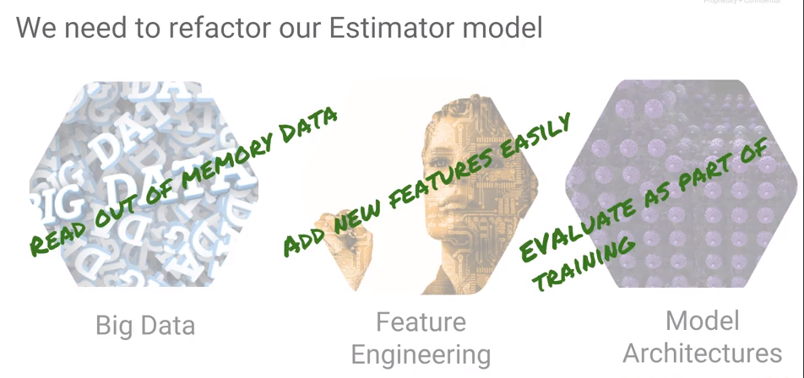Refactoring is a software engineering term that refers to changing the design of your program without adding any extra features. Often, the reason to change the design of your program is so that it can do extra things. Some things we may want to do:

1. handle data that is too large to fit in memory
2. add new features easily
3. consider different model training architectures
4. perform the model evaluation as part of our training. That makes it easier to try out different model architectures and choose the one that works best.

Consider the part that we skipped, the middle layer, which is about components that are useful when we're building your network models. In order to read data from out of memory we store and read data from many files.

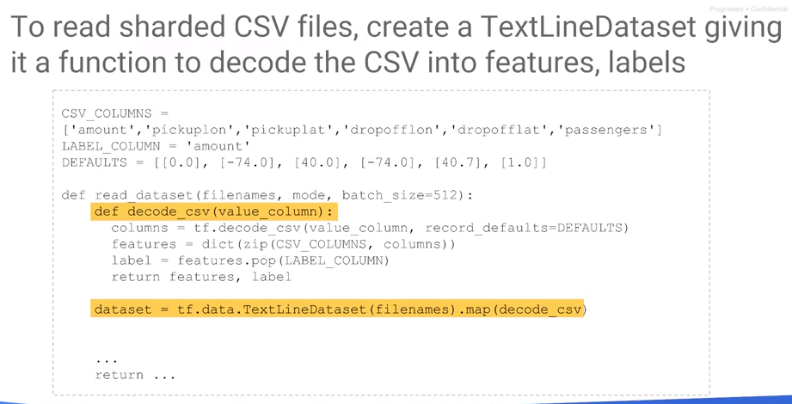Consider three files A, B, and C. When we perform gradient descent, we train over a number of epochs. That means that we go through the data number of epochs times. Going through the data set epoch times is the same as going through the entire training data once as long as it is repeated epoch times. To do that, create a file name Queue that has 50 As, 50 Bs, and 50 Cs in it, then going through this file named Queue once. Then instruct TensorFlow to go through this data once and then training is done.

We could just take our file names A, B, and C and simply repeat them A, B, C, A, B, C, A, B, C, etc. But when you're doing distributor training that becomes somewhat problematic. The reason it becomes problematic is that usually the files are not all the same size or same complexity. Perhaps processes are done in different machines and some machines are faster than others. Therefore, one of these files could cause a slowdown and we want to ensure that that slowdown is not caused at the exact same machine each time. Therefore, a good practice is to randomly shuffle when you add: take these filenames, and rather than add them in order A, B, C, A, B, C, A, B, C, etc, each time we add, we permute the A, B, and C and add them.

Now that we have a (randomly shuffled) filename queue, set up a number of readers. These readers will all be on different machines even and each reader is will go to the Filename Queue to pop the next file to process. The readers take these files, decode them and keep adding examples to the Example Queue. Then, TensorFlow reads the data out of this Example Queue. That is a way to set up reading data in batches.

How does a code work? To read a CSV file, use a wild card to retrieve all training files, e.g., “train.*” Commonly, files are sharded as train-0 of 36, 1 of 36, 2 of 36, etc., so train-* will retrieve all of the training files. That is your input file names.

Take the input file names and repeat them num_epoch times in a shuffled way, and then we get our filename_queue. Then, set up readers that are going to do the decoding. The reader in this case is a TextlineReader because these are CSV files. The reader will read a batch of records each time.

A record when read is just a line, it's a scalar, and we make it a tensor with viewing expand dims, a tensor with the same shape. That becomes the value. It is just a string - instruct TensorFlow to do decode the CSV.

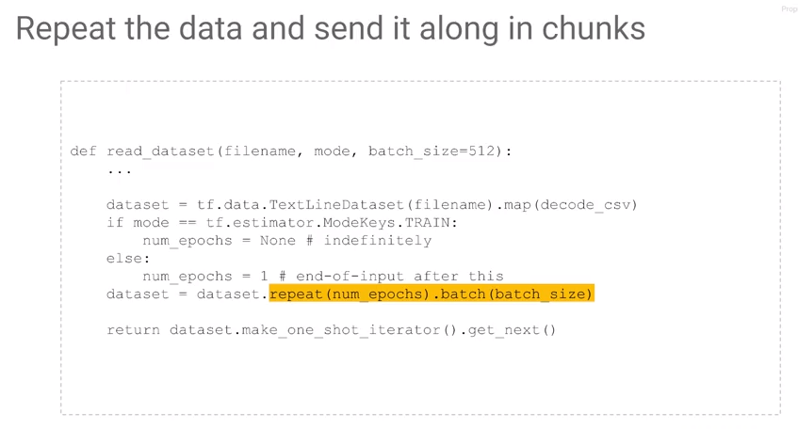Tell TensorFlow what the data types are and what to do if in the CSV, that field is empty. Missing values must be imputed in some way – one method is to specify a default value of the correct data type.

The features from the input function, have to be a dictionary where each column has the name of the column in it. Use “zip” in Python which when given two arrays as input, associates a first item of this array with the first item of the second array. This combines values from which a dictionary is created. This represents a tensor, each of these tensors is batch size elements long. These are the features. However, the target value or the value to predict is not a feature. Remove the LABEL_COLUMN for the target to specify it as such.

TextlineReader in TensorFlow not only reads from local files, it also reads from Google Cloud Storage. What these lines of code do is that they decode the CSV, they create a dictionary of features, and then we're returning the label, and the dictionary of features from the CSV.

## Lab: Refactoring to add batching and feature creation

Review: <https://www.coursera.org/learn/serverless-machine-learning-gcp/lecture/3gwBF/refactoring-lab-review>

## Train and Evaluate

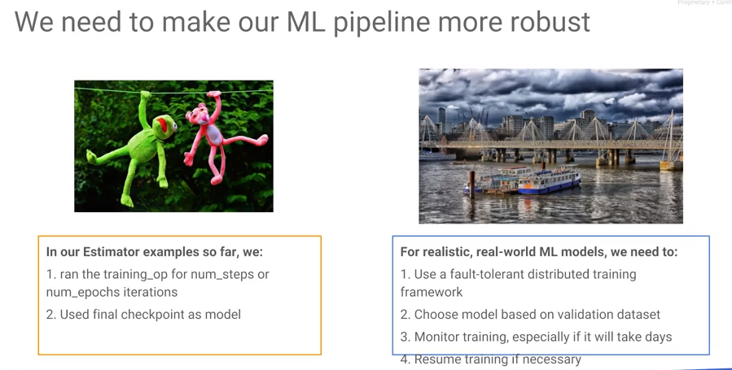

So far our TensorFlow model has not been very robust or flexible. For example, during the training process, we specified the number of steps that we needed to train. But we know in machine learning that oftentimes as you train, your training error and loss on the training dataset will keep going down. However, the model will not generalize the more you train it; at some point, the validation error starts to increase. Therefore, training should stop at the point that the error on a validation dataset stops decreasing – this is a form of early stopping.

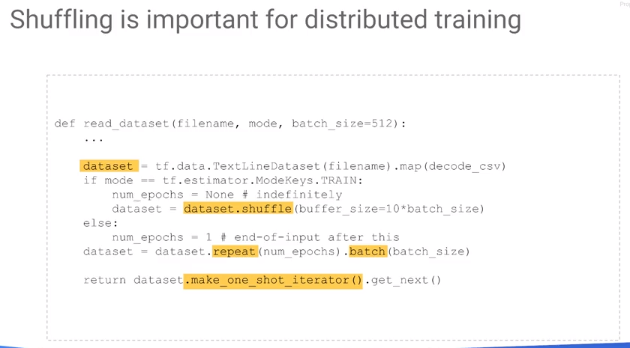

While training, continually save checkpoints such that if the training is killed, we can restart it at the checkpoint location. In this example, we execute a specific number of steps and epochs and use the final checkpoint as a model. However, we may not want to use the latest checkpoint. In the real world, we want to train in a distributed way over multiple machines. Therefore, we desire the model that gives us the best generalization performance. Stated another way, this is the model that gives the least error not in the training set but on a validation dataset. Even as the model is training, we might want to monitor the training, especially if the training is going to take days on end. Consider:

* What epoch is currently being processed?
* What is the current error? Should I stop the training, is it not improving?
* If you stop the training, and you come back and you have more data, you might want to start back the training often already trained model, you don't want to start from scratch again.
* You want to be able to resume training. We want to be able to start training back.
* We want to be able to do distributed training.
* We want to be able to choose a model based on a different validation dataset.
* We want to be able to monitor the training. So even though our TensorFlow model so far got us from point a to point b, essentially we've been just going through in a very haphazard way. What we want is a bridge that gets us from a to b, gets us from raw data to a machine learning model in a much more robust manner.

The way we do this is to use the Experiment class. In the estimator API, you the Experiment class is created passing in a particular estimator, e.g., LinearRegressor. We create the model exactly the same way, passing in the feature columns, passing in an output directory which may be a local directory or a folder on cloud storage.

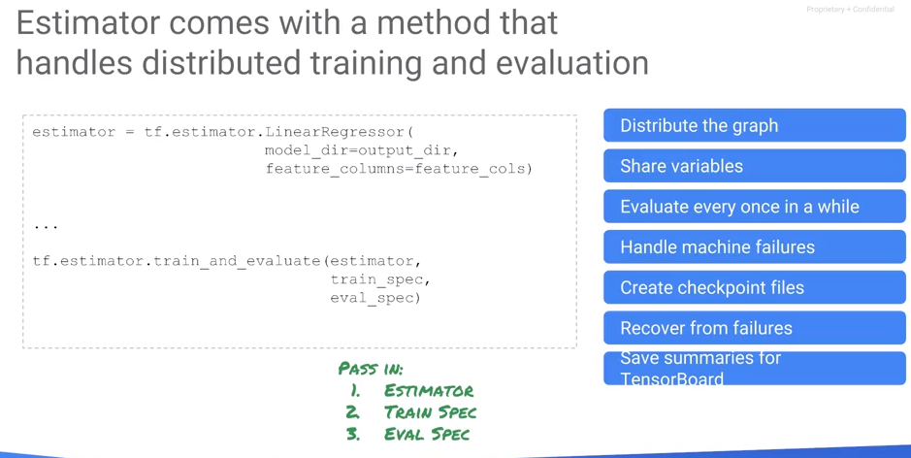Pass in the training input function which gives features and labels as a dictionary of features and the corresponding labels it loads up the training data.

Pass in an evaluation input function, which loads up another piece of data, the validation dataset, which works very similarly. It also has a dictionary of features. It also has a label. The difference is that the training dataset is the one that we are actually using for gradient descent. The validation dataset is the thing that we want to use to stop the training, to do early stopping, to do hyperparameter tuning, etc.

Also, tell the experiment which metrics to evaluate, e.g., the root mean squared error. There is already a built-in function that computes a root mean square error. This is useful because you may want to train on a particular last metric. But when you're reporting the error, that may not be the last metric that you want to report for example in classification. Other options include training on cross entropy, or accuracy and/or precision and/or recall, etc.

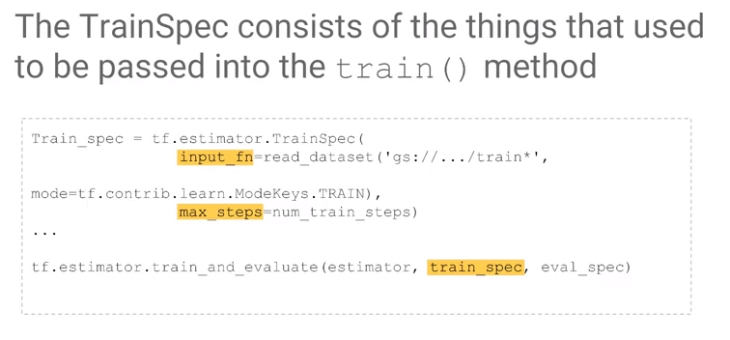Once you have the experiment, you have a callback function that creates an experiment that returns it, and you run that callback function in something called a learn_runner.

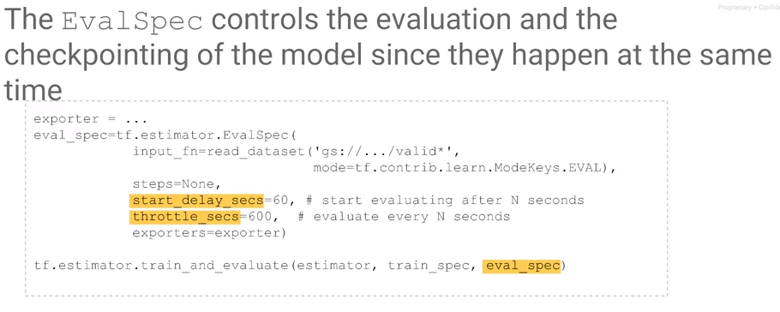

When looking at log files at the INFO level (see below), we get more information about the step such as the loss of the particular step, etc.. Don't look at the loss here. The loss here is essentially a loss at that particular step. Remember that you do gradient descent on a batch at a time. This loss is going to be quite noisy. What you really care about often is the evaluation metric. The one that's done over the entire batch. In other words, use RMSE instead of loss.

## Monitoring

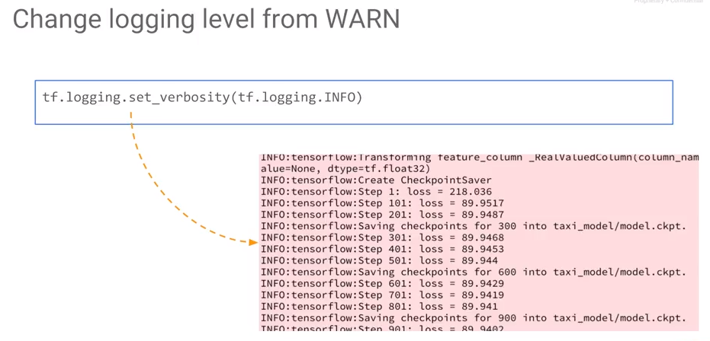

How do you monitor training? One easy thing is to set your verbosity level at INFO. By default, TensorFlow's error logging level is at WARN which is not very verbose. The levels are debug, info, warn, error and fatal. If you want TensorFlow to show loss as it trains, change the error level to INFO or change it to DEBUG.

TensorBoard is a graphical way to monitor training which comes with TensorFlow. TensorBoard uses the model output directory, whether it's a local directory or on cloud storage. TensorBoard is a collection of visualization tools, that are especially designed to help you visualize TensorFlow models and the training of TensorFlow models.

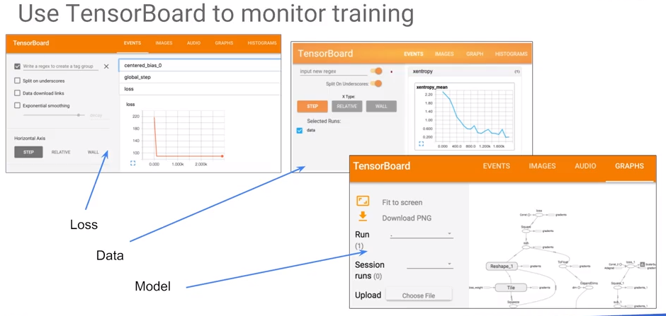

## Lab: Distributed Monitoring and Training

Review: <https://www.coursera.org/learn/serverless-machine-learning-gcp/lecture/ToWBd/lab-review-distributed-training-and-monitoring>

Code: <https://nbviewer.jupyter.org/github/jeffreyrnorton/GoogleCloudPlatformNotes/blob/master/labs/GCP_estimator_traineval.ipynb>

# Module 3: Scaling ML Models with Cloud ML Engine Introduction